Lab: Editable Detail Views

In this lab, you will modify the Contact Analysis page to make editable the referenced detail view panel.

Requirements

This lab requires that you use TrainingApp 8.0, Guidewire Studio 8.0, and Chrome as your web browser. To view, edit, and delete various contacts, log in to TrainingApp as Alice Applegate. The default URL for TrainingApp is <http://localhost:8880/ab/ContactManager.do>. The login/password for Alice Applegate is aapplegate/gw.

1. Configure the PCF File

In this exercise, you will configure ABContactAnalysisPage.pcf to make editable the referenced detailed view panel.

Configuration

1. Open Guidewire Studio for TrainingApp
2. From Studio, if your server is not already running, start the server using Debug 'Server'.
3. Review the Debug console for errors.
4. Verify that the application is running in the Debug console.
5. Navigate to ABContactAnalysisPage
6. In the canvas, hide included sections.
7. Add a toolbar with Edit Buttons
8. In the canvas, add a toolbar with Edit Buttons (Edit|Update|Cancel) to the top-level container widget.

Verification

1. Log in to TrainingApp
2. Log in as Alice Applegate.
3. Reload the PCF changes
4. In TrainingApp, reload the PCF file changes.
5. Edit the Analysis page for William Andy
6. Search for William Andy and select the search result.
7. In the sidebar menu, click Analysis.
8. Edit the Contact Analysis details for William Andy. Fraud Investigations should not be editable.
9. Click Update.

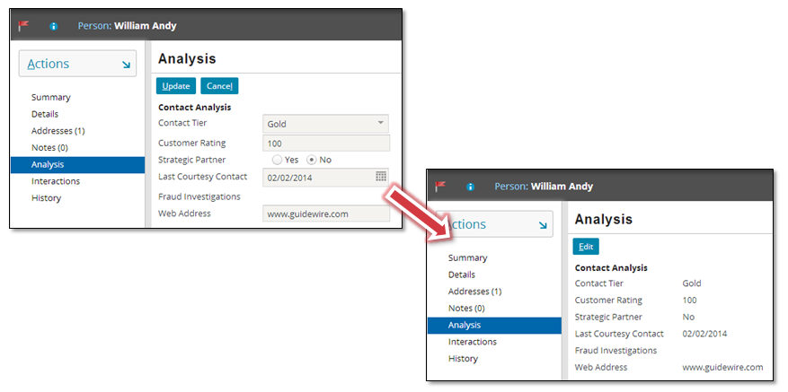

Write it down

In the sidebar menu, click Details for the William Andy contact. Next, select the Analysis card. Click Edit. Why is it possible to edit the Contact Analysis details on the Details page?

|  |
| --- |
|  |

|  |  |
| --- | --- |
|  | Stop and ask your instructor to review your completed lab. |